University of Utah
Student Maya Research Opportunity in the Mirador Basin, Guatemala, 2019
University of Utah / FARES Foundation
The University of Utah Guatemala Archaeological and Ecological Research Program is located in the remote Mirador Basin in the northern department of Peten. The research encompasses one of the most exciting research projects on the ancient Maya, and is focusing on the origins, incipient dynamics, and collapse of Preclassic Maya civilization. Under the direction of Dr. Richard Hansen, you will have the opportunity for original research and exploration in the largest and earliest ancient Maya cities with teams of scholars from a variety of disciplines.
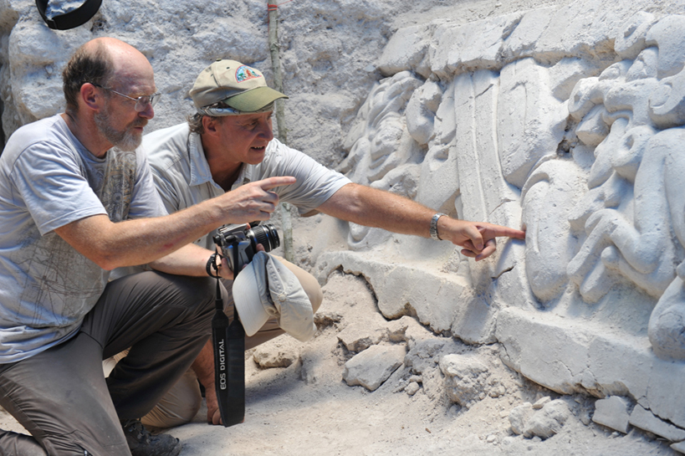
University of Utah student Craig Argyle and Dr. Richard Hansen examining the Preclassic Maya stucco frieze at El Mirador that he excavated.

The U of U research opportunity offers students the chance to be on the cutting edge in the application of sophisticated technology, excavation and research strategies and methodologies, innovative conservation measures, and theoretical considerations relative to the origins and demise of complex societies. Experts and scholars from more than 66 universities and research institutions will provide the intellectual backdrop. In addition, epigraphic expert Dr. Stanley Guenter will assist in teaching the Introductory Maya Hieroglyphic Writing course as well as a more advanced course for students who are beyond the introductory level. This will allow students to know and understand the fundamentals of Maya writing and calendar systems.

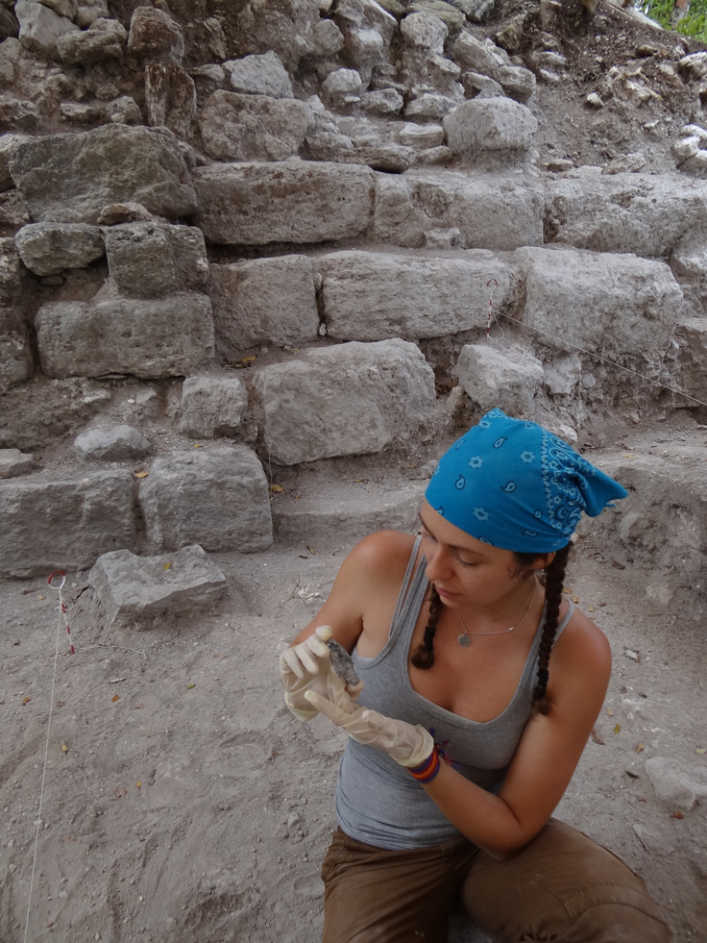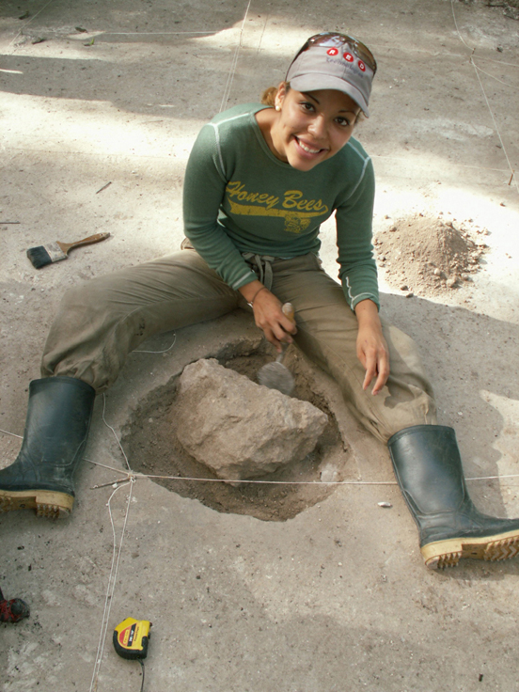

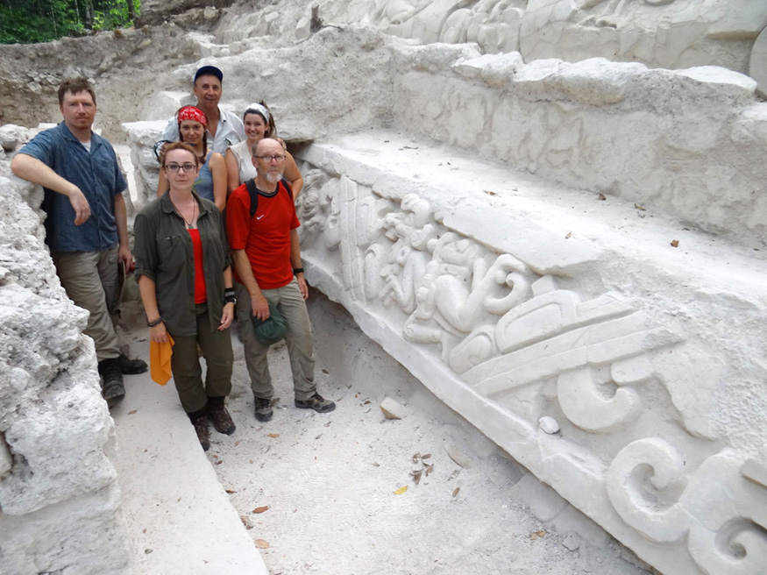
University of Utah and field research students and staff at El Mirador.

Field Work Description
The Mirador Basin Project offers the student unique field experience in Lowland Maya archaeology. Students will hike into the Basin from a small village, providing observations of the variations of tropical flora, fauna, and archaeological sites. The primary base will be the site of El Mirador, where students will be assigned to specific excavation, conservation, and investigation projected depending on skills and interests. Students will work closely with technicians and experienced scientific personnel. Students will gain and understanding of excavation and research strategies, Maya ceramics, lithics, bone and shell collection, architectural consolidation and conservation, and chronometric methods. Students will gain an understanding of Maya art and architecture, archaeology and tropical forest ecology. A basic understanding of mapping using sophisticated technology in tropical forests, radar instrumentation, and remote sensing will be available. Additional knowledge of stabilization, consolidation, and architectural conservation measures will be obtained from experts working on site.

Students will have the opportunity to tour museums in Guatemala as well as Tikal National Park.
Duration and Travel: June 26-August 5, 2019. Students may stay later with the project at no additional cost.
*Note: The starting date may vary a few days one way or the other depending on weather factors and government obligations.

-Roundtrip Airfare: Student obligation from residence to Flores/Santa Elena, Peten,
Guatemala. Bus tickets can be obtained in Guatemala City to Flores, if traveling independently, but the project does rent a bus for the transport of staff and personnel and students would have the opportunity to use this service.

ACCOMODATIONS
Students will be housed in personal tents at the field camp locations. A list of mandatory
equipment and personal belongings will be supplied approved applicants.
Meals and laundry services will be provided by the project.
TUITION AND FEES: Academic Courses 3 credits
I. Guatemala Field Research
ANTH 4962 Undergrad / 5962-008 Graduate work
1-3 credits, $75 admission fee, $1377 Undergrad / 3 credit hrs.
$1699 Grad / 3 credit hrs.

II. Intro Maya Hieroglyphic
Writing, Level 1, Level 2
ANTH 4962 / 5962 - 009
3 credits $1377.00 (undergrad); $1699 (grad)

All students must apply to the University of Utah, Dept of Anthropology
Admission applications can be accessed at: http://www.anthro.utah.edu/

ADDITIONAL FEES
-$1350 Field School Fee (all students)
-Roundtrip airfare to
Guatemala
-Medical Evacuation
Insurance, personal medical
Insurance

INQUIRIES
U of U Anthropology Department
Email: Audrey Grisham Audrey.grisham@anthro.utah.edu, Shawn Carlyle shawn.carlyle@anthro.utah.edu and Richard Hansen <rhansen@pmt.org>
Visit our web site at
& www.miradorbasin.com
Application and fees deadline: May 1, 2019
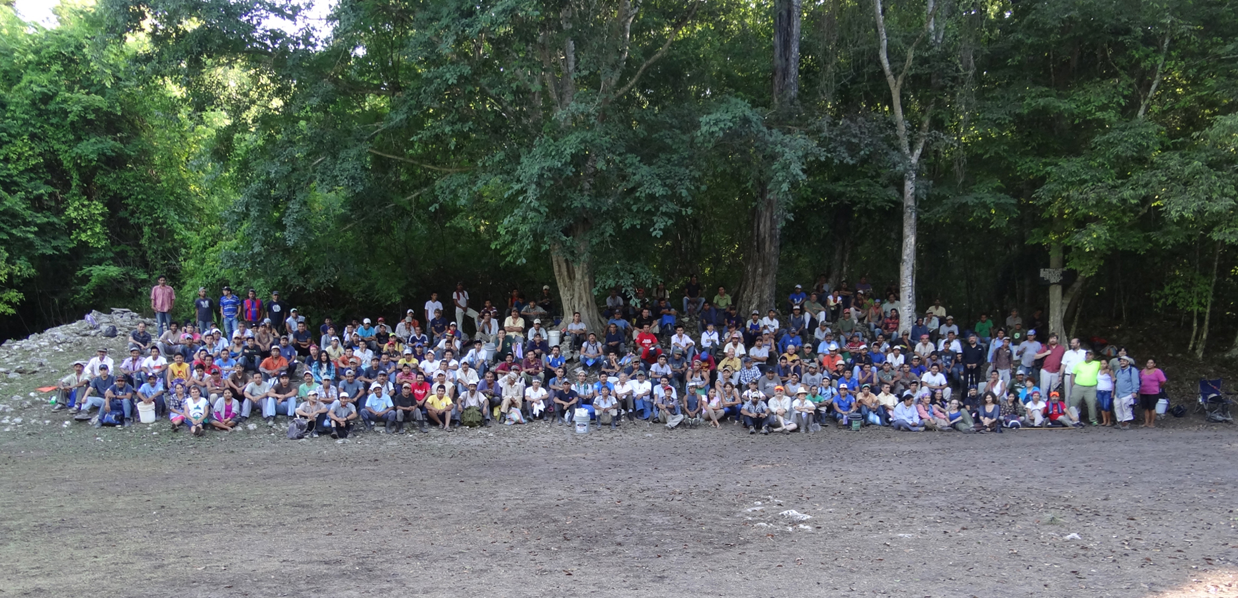

Staff and personnel at El Mirador

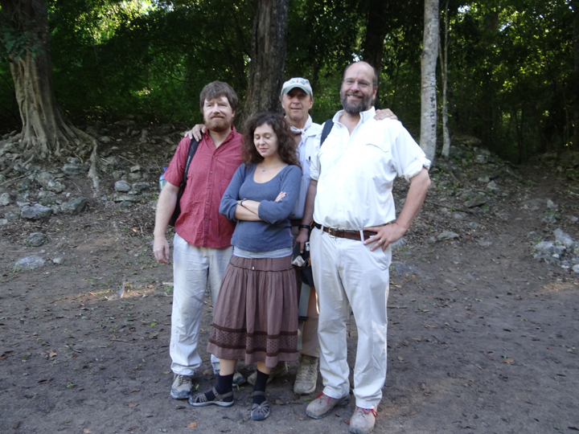
Dr. Stanley Guenter (FARES), graduate student Jordan Krummel (U of Arizona), Dr. Richard Hansen (U of U), and Dr. Richard Paine (U of U) at El Mirador, 2015

